March 18, 2024
Ref: IIH/MD/2024/03/016

His Excellency,
The Executive Governor of Kwara State,
Government House,
Ahmadu Bello Way,
GRA, Ilorin, Kwara State

Your Excellency Sir,

REQUEST FOR APPROVAL FOR RELEASE OF FUNDS TOWARDS VISIT TO HONORABLE MINISTER OF COMMUNICATIONS, INNOVATION & DIGITAL ECONOMY ON MARCH 25, 2024
We have received a response from the previous email sent to the office of the Honorable Minister for Communications, Innovation & Digital Economy requesting an official visit by a delegation of officers from Kwara State related to the portfolios of the Ministry. We have been invited for the visit on the 25th of March, 2024 by 1pm.

I write to request for your approval for the release of funds for costs related to this trip.

A breakdown of costs is given below:

SN |  | Qty | Rate | Amount
1 | Flight Tickets (ILV-ABV, ABV-ILV) | 2 | 150,000 | 300,000
2 | Hotel Accommodation (1 night) | 1 | 70,000 | 70,000
3 | Local Transport | 1 | 50,000 | 50,000
4 | Duty Tour Allowance | 1 | 30,000 | 30,000
 | Sub-Total |  |  | 450,000
 | Service Charge + VAT 20%** |  |  | 90,000
 | Total |  |  | 540,000

Yours sincerely,
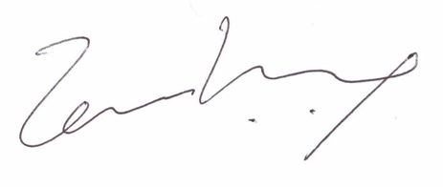
Temi Kolawole
ag. Managing Director

